COVID-19 NOTICE
SAFETY UPDATE

PLEASE READ

As part of an ongoing statewide effort to prevent the spread of COVID-19, Georgia State Parks & Historic Sites strongly encourages guests to practice social distancing and follow guidelines for hygiene while visiting the parks. This applies to our Park Rangers as well. They are passionate about their jobs and providing opportunities for people to recreate in, but their health and well-being is important too.
While in the VC/IC/Museum – edit to state facility name Park Staff will encourage all visitors:
- To maintain a 6’ social distance between all visitors and staff.
- There should be no groups of more than 10 people.
- Visitors are encouraged to wash hands and/or use hand sanitizer frequently.
- Visitors are encouraged to wear cloth face coverings in all public settings.

For the latest updates on park status visit: gastateparks.org/Alerts

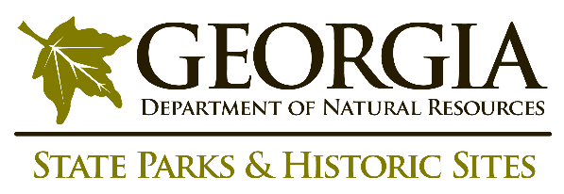
The safety and welfare of staff and the public is a top priority for the Georgia Department of Natural Resources, as we continue to monitor COVID-19 guidance from the Center for Disease Control and Prevention.
FOR IMMEDIATE EMERGENCY ASSISTANCE PLEASE DIAL 911

